SEABCRU CAVE BAT SURVEY PROTOCOL
FOR SOUTHEAST ASIA

Bats fly mainly at night and spend the day in roosts which shelter them from extremes of temperature, other climatic variables and predators. Caves and other subterranean roosts are critical to the survival of hundreds of bat species worldwide, since they often provide shelter for most of a nation’s bat fauna. As the threats to cave bats in Southeast Asia are many, there is a need for greater survey effort across the region to identify and protect caves supporting the highest diversity of bats and populations performing key ecological functions. Locally, there is also a need to: 1) Develop cave management recommendations that recognize scientific, cultural/religious and economic values of caves and protect the bats; and, 2) Monitor cave bat populations to assess effectiveness of management approaches. To this end, this document provides guidance for surveying and sharing research findings on cave-dwelling bats in Southeast Asia.

1. Identify research question(s)

Before visiting a cave, consider carefully what exactly you wish to know. The cave-specific questions that address current information needs for conservation in Southeast Asia are:

- What bat species occupy the cave?
- How many individuals of each species are present?
- Has the cave been disturbed by people? How?

Answers to these questions across the region will facilitate conservation planning on an international scale. Once standardized cave survey methods have been established, repeated surveys on a monthly or annual basis will document changes in species composition, population sizes and the effects of disturbance over time.

2. Pre-survey tasks

Permission should be obtained from the relevant authorities before any field survey. Where the location of caves is not known, literature review and local knowledge is invaluable in identifying potential survey sites. A useful first step is to compile a register of caves in and around an area. This can be updated as new information becomes available and include the following:

- Cave name  - Name of nearest village and access  - GPS coordinates  - Altitude and orientation of cave entrance  - Length and depth of cave  - Width and height of main passages  - Access difficulties (if relevant) | - Cave map available? (yes / no)  - Are bats present? (with details if yes)  - Presence of guano (present, harvested, absent)  - Presence of water  - Humidity (dry / humid, season observed)  - Notes on other cave wildlife  - Information sources (including names and contact details of sources)

3. Initial cave assessment

Surveys of cave-dwelling bats can be done at any time of year, but for a basic assessment should be conducted at least twice a year in different seasons. The time needed to survey a cave depends on its size and complexity, but 2-4 days should be sufficient in most cases.

Cave Surveys - Safety Considerations

Caves present special hazards and while sites must be judged individually, novices should not enter a complex cave unless accompanied by an experienced caver. Very large bat colonies in poorly ventilated caves can raise carbon dioxide (CO₂) and ammonia (NH₄) to harmful levels, and other non-organic poisonous gases can also be present. Histoplasmosis is a risk in poorly ventilated caves with large guano accumulations and use of respirators is advised in these. Caves and their biodiversity are highly vulnerable to disturbance and all survey methods and equipment used should comply with minimum impact practices (e.g. Jones 2009). Surveyors should also remember that bats are very sensitive during maternity periods and ensure minimal disturbance.

The first step in cave assessment is to determine whether bats are present. As many species use caves on a transient basis, either seasonally as maternity roosts or nocturnally as feeding roosts, their absence during a single visit does not necessarily mean that the site is unused or abandoned. Past and present use of caves by bats and people can be determined in the following ways:

- Directly observing bats at roost in the cave. While many bat species prefer to roost in clusters, some species roost singly while others prefer to roost in crevices which can be easily overlooked. Bat detectors are useful for detecting such species (see section 4.3).
- Fresh guano is the most obvious evidence of recent use by bats and the size of guano deposits can give a rough idea of population size and length of occupancy (provided it has not been harvested by people). Fruit bats and insectivorous bats produce different guano and this can be used to determine which are present. Insectivorous bat guano usually appears as small pellets containing tiny pieces of insects, whereas fruit bat guano lacks these fragments and is usually softer and relatively shapeless, with a smoother texture.
- Remains of bats on floors and stains on walls and ceilings from bat skin oils and urine indicate past bat use (Fig. 1). Wall stains should not be used to estimate time since last occupancy, although if large areas are stained and only a few bats are present, this may mean a colony has declined in size or varies seasonally.
- Evidence of human use typically includes footprints, garbage, graffiti, rock scratches, fire pits and religious items such as burnt incense and other offerings. The presence of long sticks and fragments of fishing nets usually indicates that bat hunting has occurred at a site.

Data on the above should be systematically recorded on standard field forms for each cave (see examples in Appendices 1 and 2) and interviews with people living nearby can also provide a great deal of information on local cave use (see section 5).
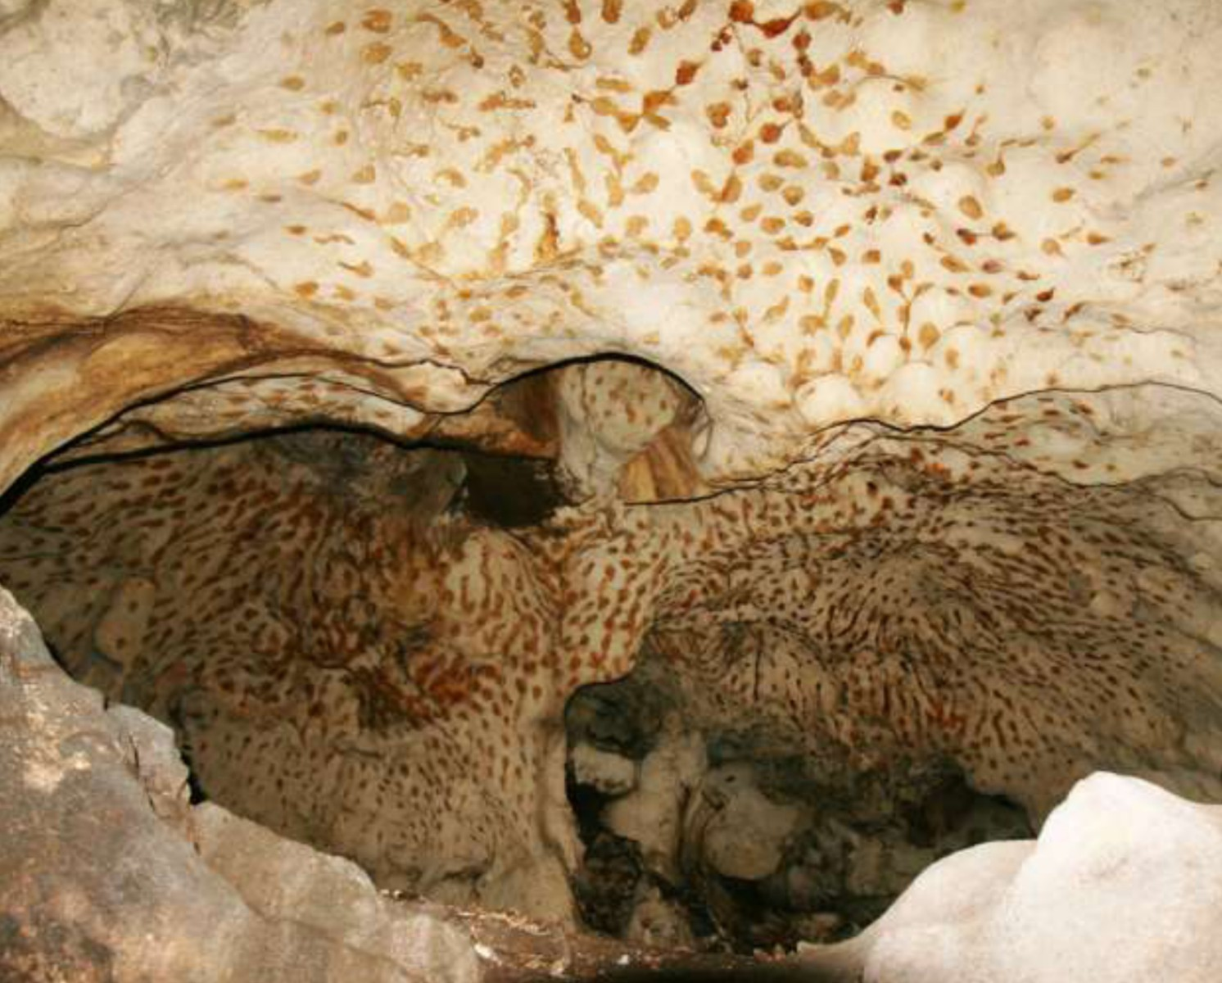

Fig. 1: Stains from bat skin oils inside a cave

4. Deciding bat survey methods

All caves are different. The most effective method for surveying bats largely depends on each cave’s physical characteristics and the size and species composition of its bat colony. Before deciding survey methods, it is helpful to watch the evening emergence of bats as this can indicate:

- How many bats use the cave (a few, many, or thousands)
- What types of bats use the cave (especially if bat detectors are used)
- Where bats exit the cave (important when a cave has multiple entrances)

Three methods are commonly used in cave bat surveys: live-trapping, acoustic and visual surveys. Depending on the cave situation, these can be used singly or in combination. Guidance on choosing survey methods is given in Fig. 2. All of these methods have individual strengths and biases which are summarized in Table 1 and explained in more detail in sections 4.1-4.4.

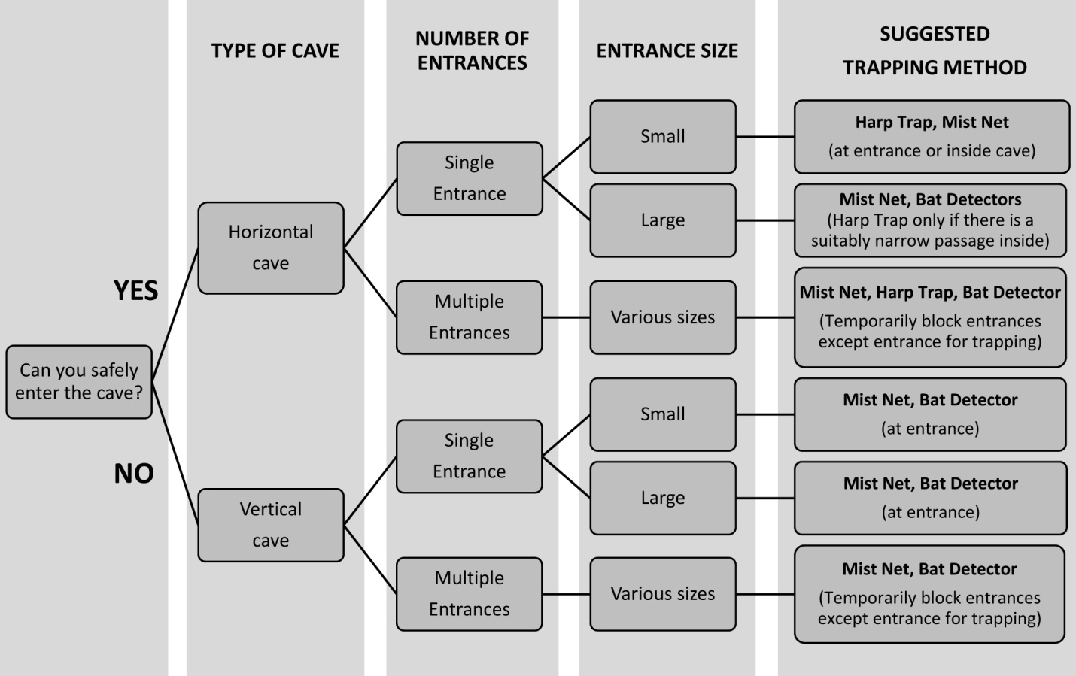
Fig. 2: Deciding survey methods for cave bats

Table 1: Strengths and weaknesses of different survey methods
Method | Target species | Location | Biases
Mist nets | Pteropodidae, large Hipposideridae and Rhinolophidae, Vespertilionidae, Emballonuridae, Miniopteridae | Cave entrance or narrower passages inside cave | May miss echolocating species that can detect and avoid nets
Harp traps | Rhinolophidae, Hipposideridae,  Vespertilionidae | Cave entrance or even narrower passages inside cave | May miss fruit bats and species preferring wider flyways
Hoop or hand nets | Bats roosting in erosion domes and crevices | Erosion domes and crevice openings | Limited area, targeting only a few roosting bats within reach
Bat detectors | Loud / low-frequency (usually larger) echolocating bats | Inside cave or during evening emergence at entrance | May miss bats with quiet / high-frequency calls (e.g. small Hipposideridae)
Visual observation | Species with distinct morphology/ behavior | Inside small caves or during evening emergence at entrance | High probability of incorrect identification

4.1 Live-trapping surveys

As determining the importance of a cave for bats requires knowledge of their identity, hands-on examination is usually needed to ensure reliable species identifications. Before attempting to capture bats however, consider the justification for catching in view of the potential for injury and disturbance. Once caught, great care is needed to ensure each bat is quickly and harmlessly processed. Surveyors should arrive at the site two to three hours before sunset to allow time for placement and setting up of traps.

Live-trapping Methods

Harp traps are effective in capturing echolocating bats (Fig. 3a) inside and outside caves. Due to their small size and ease in extracting bats, they work best in narrow flyways and where modest numbers of bats are expected. Four-bank traps are recommended. Sampling effort can be expressed as harp-trap-nights (htn), harp-trap-hours (hth) or metres-squared harp-trap-hours (m²hth). Given their small size, the efficacy of harp traps at larger caves may require placement at smaller passageways inside the cave or combination with mist nets as part of a funnel arrangement. They should always be attended while in use, as captured bats are vulnerable to predation and stress.

Mist nets are effective in capturing fruit bats and larger insectivorous species that prefer wider flyways in and outside the cave. Available in a range of sizes, these are useful for live-trapping bats in most cave situations (Fig. 3b). Sampling effort is best expressed as metres-squared mist-net-hours (m²mnh). The greatest issue with mist nets is that bats can become badly tangled in nets or hurt during extraction. Large colonies of bats can fill mist nets at entrances very quickly when exiting caves, so these should be attended continuously and if necessary quickly moved to stop captures. Care should be exercised in removing bats and always be prepared to cut the net to free tangled individuals. When using mist nets over water, the lowest part of the net should be well above the water level so that captured bats avoid getting wet or even drowning.

Hoop or Hand nets can be used to capture bats in confined spaces where other traps cannot be used. Kite-shaped nets are often more useful, particularly when bats are in corners, although folding circular nets are easier to carry. Hand nets should only be used to catch bats at roost and should not be swung inside caves as they can easily hurt flying bats. Large versions of hand nets can be useful in catching flying bats where these are avoiding traps or where traps are ineffective due to low population densities. They generally consist of a section of fine-meshed net (i.e. 2 x 2.5 m) strung between to two handheld poles (such as carbon fishing rods) and can be made fairly easily. Mist net material should not be used as bats can become tangled too easily.

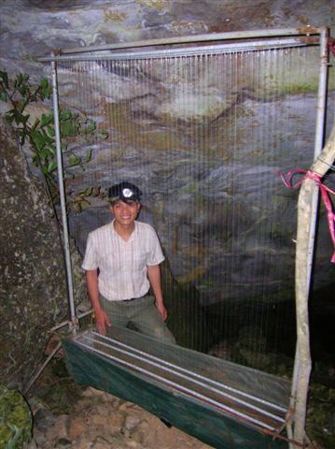
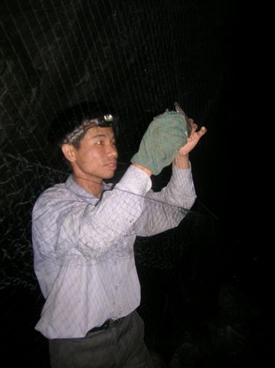
a
bb

Fig. 3: Live-traps used for bat surveys: a) harp trap, b) mist net

4.2 Processing bats in live-trapping surveys

The aim of processing is to record key information and release all bats captured as quickly and harmlessly as possible. This is particularly important for bats caught leaving caves in early evening, as they will not have fed and can die of hunger. Unless processing can be done immediately, each bat can be kept in an individual cotton bag for no more than one hour.

The following information should be recorded for bats captured: date, survey location, time of capture, species, forearm length, weight, sex, age and reproductive status. A bat capture data sheet is given in Appendix 3. Photographs are also useful for documenting species identifications in the field. See Francis (2008) for keys for identifying Southeast Asian bat species, and Kingston (2014) (SEABCRU Bat Research Techniques Manual v.1) for the use of keys.

If large numbers of bats are caught during a live-trapping session, processing of these should be expedited by simply counting and immediately releasing the most common species whose identity is known and temporarily keeping a small number for more detailed examination.

Handling Bats: Safety Considerations

Bats carry a number of diseases that can infect people, most of them viruses. In Asia, this includes Nipah virus, SARS coronavirus, Ebola Reston virus, and lyssaviruses. Some of these have a very high fatality rate. Other new viruses whose effects on human health are unknown have also been recently found in bats. Because the consequences may be very severe, protective measures to reduce the chance of contracting a disease are strongly recommended. These include wearing Personal Protective Equipment (PPE) when working with bats and practicing general safety procedures in handling them.

Anyone who wishes to work with bats should first complete their pre‐exposure prophylaxis rabies vaccine, and should get their titer checked every two years afterwards, getting booster shots when need. When handling bats, we recommend wearing dedicated clothing (=long sleeve shirt and pants that stay at the field site, and/or are dedicated to wearing only during field work), covered shoes, nitrile gloves, a mask (N95 or P100), and eye protection (safety goggles or glasses). Further guidance is given by Newman et al. (2011) and the SEABCRU Recommendations for Personal Protection and Safety can be found at www.seabcru.org/seabcru-resources. The SEABCRU Recommendations were developed for working with flying foxes, but the principles of risk assessment are directly comparable, and most caves present a high risk of exposure to falling urine and feces.

If unknown or cryptic species are encountered, collection of voucher specimens may be necessary to confirm their identity through later examination. Permission must be sought from the relevant authorities before collecting voucher specimens. Specimen collection should be confined to males and minimized, aiming only to include the most significant differences among captured bats in external morphology, external measurements and fur coloration. Further guidance on collecting and preserving voucher specimens is given by Kingston (2014)

4.3 Acoustic surveys

Acoustic surveys inside a cave and at its entrance are a useful low-disturbance approach to surveying cave bats. Insectivorous bats emit mostly inaudible (ultrasound) echolocation calls that are often unique to species and these can be used for species identification. Reference calls from known bat species are needed to identify calls recorded from free-flying bats. As many bats can perceive and avoid live traps, bat detectors are an important complement to these methods. As with other approaches however, bat detectors also suffer limitations. For example, species with quiet calls may not be detected and not all species can be identified acoustically.

Reference calls for each species should be recorded from the area surveyed under as many different natural situations as possible. Detailed advice on collection and analysis of bat echolocation and acoustic survey techniques is given by Brigham et al. (2002) and Kunz & Parsons (2009).

The simplest approach is to record bats at the cave entrance when they emerge in early evening. Where simultaneous recording at several entrances or repeated monitoring of remote caves is required, automated (or passive) detectors can be used. Sampling effort is usually expressed as recording duration and its timing relative to sunset on a given number of nights. One common measure of bat activity is the number of bat passes. As bats often circle near cave entrances, acoustic data cannot be used to determine the number of individuals. However, indexes that reflect the relative density of bats calling can be used (e.g. 0 = none, 1 = one call sequence, 2 = individual overlapping call sequences easily distinguished from one another, 3 = chorus, individual calls not easily distinguished). This approach is useful for assessing relative species densities in a cave chamber or during evening emergence.

Bat detectors

Four methods of recording bat echolocation calls are commonly used: heterodyne, frequency division, time expansion and full spectrum recordings.

Heterodyne (narrow band) detectors are the least expensive and allow the listener to manually determine the frequency of bat calls although only a narrow band of frequencies (about 10 kHz) are audible at any time. Heterodyne detectors are useful for detecting the presence and activity of bats, but recordings cannot be used for sound analysis.

Frequency division (broad band) detectors are moderately expensive and differ by detecting all frequencies simultaneously so that all bats can be heard without needing to tune the unit. They allow monitoring of bat activity in real time and provide recordings suitable for analysis.

Time expansion detectors provide higher quality recordings for analysis but cannot be used to listen to bats in real time. Several of the more expensive detectors feature heterodyne, frequency division and time expansion for maximum flexibility.

Full spectrum detectors provide real-time and high-quality recordings, but generate larger file sizes which require larger storage capacity.

More detailed guidance is given by Brigham et al. (2002) and Britzke et al. (2013).

4.4 Visual surveys

Visual assessment is the best way to estimate population sizes, especially when the colony is large (e.g. one cannot possibly capture every individual).

Emergence counts are made as bats exit from cave roosts and are an effective non-disruptive method of estimating populations at sites which cannot be entered due to inaccessibility or fear of disturbance. Observers (one or more) should be in position half an hour before dusk. Counts are most effective when departing bats are silhouetted against a clear sky. Where this is not possible or where decreasing light reduces visibility and subsequent estimates, use of night vision devices and supplemental infra-red spotlights can greatly improve visibility, making all night counts possible (Fig. 4). Emergence counts may underestimate the number of bats present and should ideally be repeated over several weeks to determine intra-colony variation.

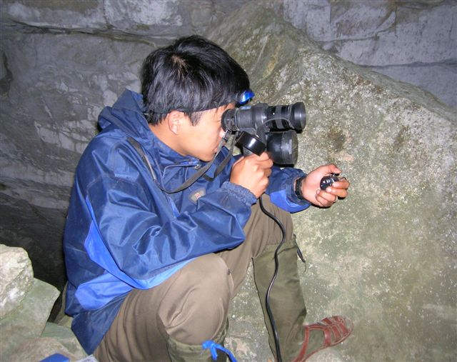
Fig. 4: Emergence count using a night vision device
(with an infra-red spotlight) and manual hand counter.

Video recording the emergence of bats using an infrared-sensitive camera combined with an infrared spotlight can also improve population size estimates considerably and in some cases provide a direct census of the bats (Fig. 5). Depending on the number of bats and the size of the cave opening, one can either count each bat with a manual hand counter using a slowed-down playback or, when there are many overlapping bats emerging, estimation methods can be used (see Hillman 2006).

Fig. 5: Video image of a bat emerging from a
cave roost lit with an infrared spotlight.

Still photography can be utilized to estimate the density of roosting aggregations of bats. Most often bats fly when people enter the roost; however, after time they may settle down and perch again. Photographs are especially useful for large colonies of fruit bats (Fig. 6) and bats roosts in ceiling depressions (solution cavities, bell holes). For an example of this method, see Carpenter et al. (2014).

Fig. 6: Rousettus amplexicaudatus roost. Average inter-orbital distance was
used to calibrate the measurement of roost area (from Carpenter et al. 2014).

5. Human disturbance
Many caves in Southeast Asia are influenced by human activity and understanding its nature, severity and effect on cave bats is central to their conservation. The three main approaches for assessing human disturbance in and around caves are direct observation, physical evidence and interviews with people living nearby.

- Direct observation is ideal in that the nature and extent of disturbance can be recorded precisely. This is often not possible however and so surveyors typically need to determine what disturbance has occurred through physical evidence and interviews.

- Physical evidence of human disturbance typically includes footprints, garbage, graffiti, rock scratches, fire pits and items such as burnt incense and other religious offerings. Long sticks and fragments of fishing nets usually indicate that bat hunting has occurred at a site.

- Interviews with people living near the cave can provide much information on the use of cave resources, how often the cave is visited and bat population size over time. However, the accuracy of interview data can vary greatly and is influenced by who is conducting the interview and the specific questions asked.

Cave Interview Information

Cave visitation and resource use
- Frequency of visits
- Purpose of cave visit (e.g. religious activity, adventure activity, guano collection, water collection, swiftlet nest collection, etc.)
- Timing of visits (e.g. prior to rice planting for guano)
- Resources extracted (e.g. guano, bats, nests, phosphate)
- Amount of resource(s) extracted (e.g. three rice sacks of guano)

Bat populations
- Presence of bats
- Number of bats
- Changes in bat population seasonally or over years
- Bat hunting

6. Post-survey tasks

When returning from the field survey, it is vital that data sheets, other field notes, and digital media (e.g. photographs, sound files, video, etc) are immediately backed up so these are not lost. It is also important to send reports on the findings of field surveys to central and local authorities. These are typically required and may include recommendations for management and conservation action.

We strongly recommend submitting your data to the SEABCRU database. By doing this, your data will be available for current and future researchers, long-term, reliable storage will be provided for your data, and this will then become a citable product (many journals require that raw data are archived and available to the public). Eventually, one will be able to submit data to SEABCRU through an online source. Until then, data should be emailed to Dr. Tigga Kingston (tigga.kingston@ttu.edu) in an electronic format, preferably as an Excel document. Spreadsheet templates and terminology can be found on the SEABCRU website (www.seabcru.org/seabcru-resources).

If you do not publish your work, it may as well never have been done at all. All too often, hard-earned data and important insights remain hidden in notebooks or donor reports that are seen by only a handful of people. Improved understanding of the conservation status and needs of Southeast Asian bats can only be gained by making research findings available in open-access journals. Just as importantly, your work will help fellow scientists, sponsors and managers decide what needs to be done next. Further guidance on writing and publishing scientific articles is given by Daltry et al. (2012) and a variety of tools for data analysis and scientific writing can be found at http://www.oryxthejournal.org/index.php/for-authors/tools.html. A list of regional and international journals that have published articles on Southeast Asian bats is given in Appendix 4.

References

Brigham MR, Kalko EKV, Jones G, Parsons S, Limpens HJGA (2002) Bat echolocation research: tools, techniques and analysis. Bat Conservation International, Austin, Texas.
Britzke ER, Gillam EH, Murray KL (2013) Current state of understanding bat detectors for the study of bat ecology. Acta Theriologica 58: 109–117.
Carpenter E-S, Gomez R, Waldien DL, Sherwin RE (2014) Photographic estimation of roosting density of Geoffroy’s Rousette Fruit Bat Rousettus amplexicaudatus (Chiroptera: Pteropodidae) at Monfort Bat Cave, Philippines. Journal of Threatened Taxa 6(6): 5838–5844.
Francis C (2008) A field guide to the mammals of South-East Asia. New Holland, London.
Daltry J, Fisher M, Furey NM (2012) Editorial – How to write a winning paper. Cambodian Journal of Natural History 2012(2): 97–100.
Hillman A (2006) Monitoring of Tadarida plicata at Khao Chon Pran Non-hunting area, Ratchaburi. Journal of Wildlife in Thailand 13(1): 31–42.
Jones C (2009) A guide to responsible cave practices. National Speleological Society, USA. http://caves.org/brochure/NSS%20Guide%2062309.pdf
Kunz T, Parsons, S. (2009) Ecological and behavioural methods for the study of bats. The John Hopkins University Press, USA. 2nd edition.
Kingston T (2014) SEABCRU Research Techniques for Bats Manual v1.0. URL needed
Newman SH, Field H, Epstein J, de Jong C (2011) Investigating the role of bats in emerging zoonoses: balancing ecology, conservation and public health interests. FAO Animal Production and Health Manual No. 12. Rome.

Appendix 1: Cave site cover sheet

Appendix 2: Cave survey data sheet
Appendix 3: Bat capture data sheet
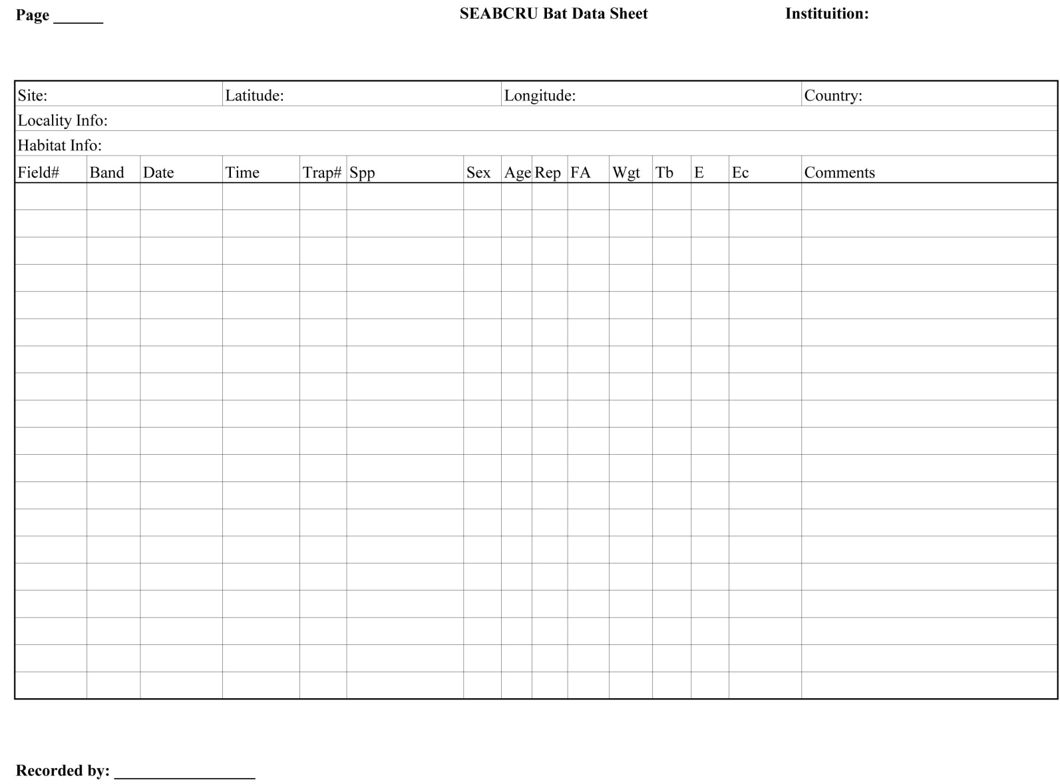
Appendix 4: Scientific journals
Regional Journals

Asian Journal of Biodiversity: http://ejournals.ph/index.php?journal=AJB
Bombay Journal of Natural History: www.bnhs.org/publications/journal-of-bnhs.html
Check List: www.checklist.org.br/
Current Zoology: www.currentzoology.org/

International Journal of Ecology and Conservation: http://ejournals.ph/index.php?journal=IAMURE-ECO
Journal of Indonesian Natural History: www.jinh.net
Journal of Biological Sciences: http://scialert.net/jindex.php?issn=1727-3048
Journal of Tropical Biology and Conservation: www.ums.edu.my/ibtp/index.php/publication/jtbc
Journal of Threatened Taxa: www.threatenedtaxa.org
Malayan Nature Journal: www.mnj.my/index.php/mnj
Natural History Bulletin of the Siam Society: www.siam-society.org/pub_NHB/nhb_index.html
Sains Malaysiana: www.ukm.my/jsm

International Journals

Acta Chiropterologica: www.bioone.org/loi/acta
Biodiversity and Conservation: http://link.springer.com/journal/10531
Biotropica: http://onlinelibrary.wiley.com/journal/10.1111/%28ISSN%291744-7429
Journal of Mammalogy: www.mammalsociety.org/journal-mammalogy
Journal of Tropical Ecology: http://journals.cambridge.org/action/displayJournal?jid=TRO
Journal of Zoology: http://journals.cambridge.org/action/displayJournal?jid=ZOO
Oryx: http://journals.cambridge.org/action/displayJournal?jid=ORX
Raffles Bulletin of Zoology: http://lkcnhm.nus.edu.sg/nus/index.php/publications/rbz
Zootaxa: www.mapress.com/zootaxa/

